Real-Time Multi-Platform Price Comparison and Smart Ranking System

Project Gantt Chart
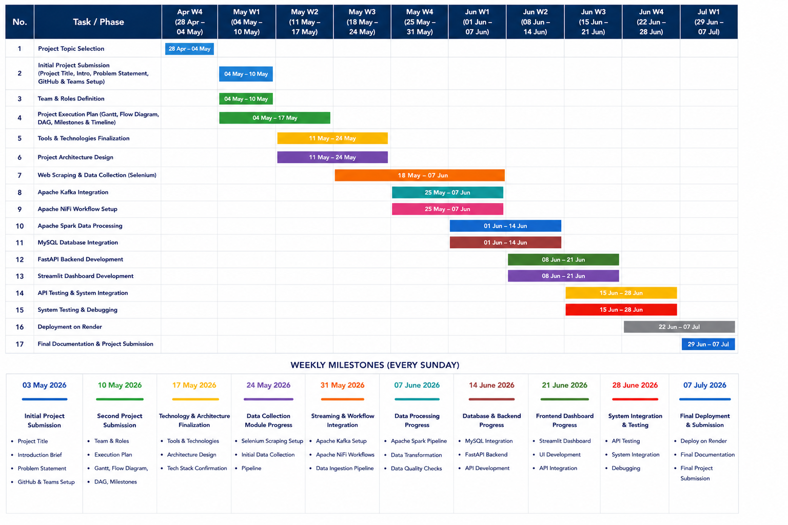

Task / Phase | Apr W4  (28 Apr – 04 May) | May W1  (04 May – 10 May) | May W2  (11 May – 17 May) | May W3  (18 May – 24 May) | May W4  (25 May – 31 May) | Jun W1  (01 Jun – 07 Jun) | Jun W2  (08 Jun – 14 Jun) | Jun W3  (15 Jun – 21 Jun) | Jun W4  (22 Jun – 28 Jun) | Jul W1  (29 Jun – 07 Jul)
Project Topic Selection | ■■■■
Initial Project Submission |  | ■■■■
Team & Roles Definition |  | ■■■■
Project Execution Plan |  | ■■■■ | ■■■■
Tools & Technologies Finalization |  |  | ■■■■ | ■■■■
Project Architecture Design |  |  | ■■■■ | ■■■■
Web Scraping & Data Collection |  |  |  | ■■■■ | ■■■■ | ■■■■
Apache Kafka Integration |  |  |  |  | ■■■■ | ■■■■
Apache NiFi Workflow Setup |  |  |  |  | ■■■■ | ■■■■
Apache Spark Data Processing |  |  |  |  |  | ■■■■ | ■■■■
MySQL Database Integration |  |  |  |  |  | ■■■■ | ■■■■
FastAPI Backend Development |  |  |  |  |  |  | ■■■■ | ■■■■
Streamlit Dashboard Development |  |  |  |  |  |  | ■■■■ | ■■■■
API Testing & System Integration |  |  |  |  |  |  |  | ■■■■ | ■■■■
System Testing & Debugging |  |  |  |  |  |  |  | ■■■■ | ■■■■
Deployment on Render |  |  |  |  |  |  |  |  | ■■■■ | ■■■■
Final Documentation & Submission |  |  |  |  |  |  |  |  |  | ■■■■
■■■■ = Active Resource

Milestones and Timeline
Milestone | Completion Date
Initial Project Submission | 03 May 2026
Second Project Submission | 10 May 2026
Technology & Architecture Finalization | 17 May 2026
Data Collection Module Progress | 24 May 2026
Streaming & Workflow Integration | 31 May 2026
Data Processing Progress | 07 June 2026
Database & Backend Progress | 14 June 2026
Frontend Dashboard Progress | 21 June 2026
System Integration & Testing | 28 June 2026
Final Deployment & Submission | 07 July 2026

